Collaborative Mediation Coaching
Pilot Zoom

To support mediator skills development
To identify/cultivate new member engagement
To promote/elevate MCDR profile

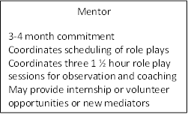
Mentor
3-4 month commitment
Coordinates scheduling of role plays
Coordinates three 1 ½ hour role play sessions for observation and coaching
May provide internship or volunteer opportunities or new mediators

Role Player C
3-4 month commitment
Role play/mediates practice scenarios
Works with assigned MCDR committee
Joints MCDR at discounted rate (20%)
Role Player B

3-4 month commitment
Role play/mediates practice scenarios
Works with assigned MCDR committee
Joints MCDR at discounted rate (20%)
Role Player A
3-4 month commitment
Role play/mediates practice scenarios
Works with assigned MCDR committee
Joints MCDR at discounted rate (20%)

Role Player F
Role Player E
Role Player D

