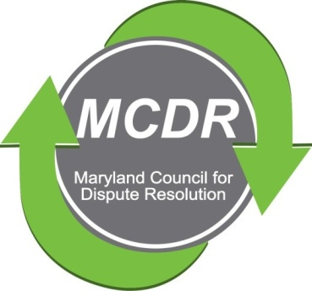

MINUTES OF THE MEETING OF THE BOARD OF DIRECTORS

Sunday, May 17, 2020

PRESENT BY ZOOM: Stirling Phillips, Merry Lymn, David Lewis,. Barry Weissman, Janne Weissman, Liz Salter, Ramona Buck and Laverne Day.

NOT PRESENT: Charles Franklin, Monette Goodridge, Ceecee Paizs. Thom McCloud (Thom McCloud and Ramona Buck alternate participation).

The meeting of the Board of Directors of the Maryland Counsel for Dispute Resolution was called to order at 6:15 p.m. and concluded at 7:30 pm.

MINUTES OF THE PREVIOUS MEETING of March 29, 2020, previouslly circulated by e-mail, were accepted.

TREASURER'S REPORT: Barry Weissman reported that our expenses are low. He has reordered brochures.

MENTORING: Stirling Phillips reported that the Mentoring Committee is considering a 10-month mentoring program. The committee plans to match mentors and mentees. The Committee decided to add questions to the mentoring applications in order to facilitate matching. It was suggested that the committee explore insurance coverage for the mentoring program. The Mentoring Committee scheduled a meeting on May 19. Liz Salter is helping Stirling.

CERTIFICATION: The certification session scheduled for May 3, 2020 was cancelled. It will be rescheduled for the fall. The Certification Committee, Ramona Buck, Thom McCloud, Martin Kranitz and David Lewis, will be meeting on June 25 to try to figure out how to set up certification sessions via Zoom.

The Certification Committee applied for a grant from MACRO. Ramona thanked Barry Weissman, Barbara Williams, Thom McCloud and Kate Kranitz for their help in preparing the grant application.

The Certification Committee is planning a retreat July 19 from 1:00-5:00 p.m. to discuss the future of certification and perhaps the IMI application. Board members are welcome to participate. Let Ramona know by e-mail if you would like to join.

PROGRAMS: LaVerne Day is planning a program for June 14 from 3:00-5:00 p.m. The focus of the program will be personal experiences related to mediating remotely. The format is a panel discussion. CeeCee Paizs would like to be on the panel. The Board brainstormed a few ideas for the title, but none was chosen.

Sarah Weissman is helping Laverne Day set up a webinar.

LaVerne is working to see how the Jeopardy Ethics game can be broadcast by Webinar or Zoom. She is also working on a program that will focus on comparing various platforms for remote mediation: Join Me; Webex; Teams; Adobe Connect; Skype; and Google.

One goal is to provide regularly scheduled webinars.

MEMBERSHIP: Janne Weissman, Membership Chair, will phone 28 people who have not renewed their membership after LaVerne sends out program information. Liz Salter will help Janne with the phone calls. Janne and Barry Weissman will be working on developing remote brochures.

BAR LIAISON: David Lewis reported that Ceecee Paizs is working with MSBA concerning the question of whether MCDR and MSBA should develop standards for attorneys attending mediation. Jody Weinberg is the MSBA representative. Merry Lymn would like to work with CeeCee and Jody on this project.

Zoom: MCDR has a Zoom business account. It is available to any of the board members if they need it for MCDR business.

NEXT BOARD MEETING: The date of the next meeting was not set.
Respectfully submitted,

Merry Lymn, Secretary

