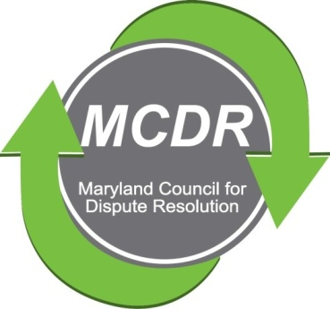

MINUTES OF THE SUMMER QUARTERLY MEETING

Sunday, June 6, 2022
2:00-4:00 p.m.

MCDR offered a program to the general membership open to the general public. In accordance with requirements of the Maryland Standards of Conduct for Mediators, attendees learned about unconscious and implicit bias. The session was facilitated by Heather Fogg. There was a very lively discussion.

No business was conducted.

A recording of the session is available on MCDR’s website.

Respectfully submitted,

Merry Lymn, Secretary

