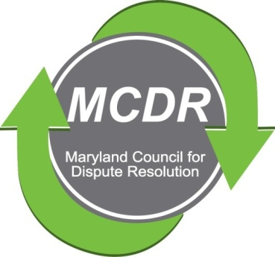

MINUTES OF THE MEETING OF THE BOARD OF DIRECTORS

Sunday, March 31, 2019

PRESENT: Stirling Phillips, Barry Weissman, Merry Lymn, Janne Weissman, Thom McCloud, David Lewis
NOT PRESENT: Monette Goodridge, Liz Salter, Ramona Buck
The meeting of the Board of Directors of the Maryland Counsel for Dispute Resolution was called to order at 6:30 pm. The meeting was held at the home of Barry and Janne Weissman.
Board meetings are held bi-monthly. The board discussed the possibility of scheduling quarterly meetings before the quarterly meetings.
Nominations
The Nominating Committee should ask for nominations at the June quarterly meeting, and prepare a slate for approval at the September quarterly meeting. Barry suggested that Ramona be asked to serve on the Committee.
April Quarterlly Meeting
The quarterly meeting is scheduled for Tuesday, April 25, 2019. The schedule as approved by the Board:
- 6:00-6:30 sign in and networking
- 6:30-7:00 mediator speed dating
- 7:00-8:30 speaker presentation by Kathy Constantino, an attorney at FDIC. The topic is "Difficult Conversations."
June Quarterly Meeting
The June quarterly meeting will be June 23 from 12:00-4:00 at the Sheraton Silver Spring. The schedule as approved by the Board:
- 12:00-1:00 Buffet luncheon
- 1:00-2:00 Founders speeches and 20th anniversary war stories, award and plaque presentation of the Sharon Pickett Award to Cam Crockett.
- 2:00-4:00 Program (qualifying for 2 hours of CLEs). The Board approved the topic "Things My Mediation Teacher Never Taught Me." It is hoped that we can obtain three speakers representing different types of mediation--facilitative (perhaps Martin or Carl), inclusive (perhaps Erica or Tracy, and transformative (perhaps Dusty Rhodes or Rachel Wall or Sherry). David Lewis emphasized the importance of including speakers from St. Mary's and Calvert counties. The Board agreed.
Barry Weissman will publicize the program and the Sharon Pickett award.
A videographer has been arranged for the award program.
Mentoring Program
A flyer seeking mentors and mentees and a mentoring booklet have been prepared. A questionnaire needs to be designed so that mentors and mentees can be matched. The program will begin with ten pairs.
The Mentoring Program needs a focus. The committee needs to develop parameters and guidelines. There is a disagreement as to whether the focus should be help with observations, education, or eventual certification. There was agreement that there should be a discussion about what mentors want to share/teach.
There is a need to look into the question of how to find observations for newly trained mediators. Some people give up because they are unable to find observations. It is not part of the training process.
Certification

Henando Botero of the American University College of Law approached MCDR to form a partnership. He wanted to expand the College's program and would have MCDR individuals assess his students and thereby obtain IMI certified training course. There is no benefit to MCDR and therefore the Board rejected it.

Nancy Hershman designed a brochure. The Board wants the revised brochure to be placed in all future packets. Thom noted that the brochure has not been finalized by the certification committee but represents the current status. The certification committee is moving to have a final document in time for the April MCDR quarterly meeting. Barry offered to be in touch with Nancy to address issues related to layout, font, etc. Barry mentioned that if he could receive a final draft five days before the April meeting there shouldn't be a problem. The Board would like the brochure to be placed in the packets.

Special Program

Thom and Stirling are working on a special feedback program for presentation to CRMC in which mediators will role play and will be assessed--something like a certification exercise.

Next Board Meeting: Stirling will canvass the Board to determine a good date for the next meeting.

Respectfully submitted,

Merry Lymn, Secretary

