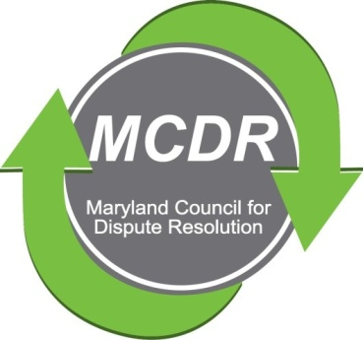

MINUTES OF THE MEETING OF THE BOARD OF DIRECTORS

Thursday, September 5, 2019

PRESENT: Stirling Phillips, Barry Weissman, Merry Lymn, and Monette Goodridge participated by telephone.

NOT PRESENT: Thom McCloud, Liz Salter, Janne Weissman, David Lewis, Ramona Buck..

The meeting of the Board of Directors of the Maryland Counsel for Dispute Resolution was called to order at 6:00 p.m. and concluded at 6:30 pm.

SEPTEMBER QUARTERLY MEETING: The Board decided that, the first choice venue for the quarterly meeting is Annapolis. The second choice is Columbia. The first choice for a date is October 7, the second choice is October 21. The Board may have made a mistake, because, in August, we had agreed that the meeting should be on a Sunday at 2:00. These dates are on Mondays. (Also, October 21 is Erev Simchat Torah and Merry, and perhaps others, will be unable to attend the meeting.)

It was decided that a note of apology for postponing the September meeting to October should accompany the ballots.

NOMINATIONS: Barry, Merry and Stirling met on August 22 and proposed the following slate:

Co-Presidents: David Lewis and Charles Franklin

Immediate Past President: Stirling Phillips

Vice President: Monette Goodridge

Treasurer: Barry Weissman

Secretary: Merry Lymn

Membership Chair: Janne Weissman

Certification Program Chairs: Ramona Buck and Thom McCloud

Program Chair: Laverne Day (Edie to serve on the committee?)

Mentoring Chair: Jamie Brooks

Maryland Bar Liason: Ceci Paisz

Member At-Large: Liz Salter

Subsequently, Stirling took a poll of the Board of Directors and it was decided unanimously that, the elections will be by email ballot. Merry, as Secretary will receive the ballots.
NEXT BOARD MEETING: No date has been decided.
Respectfully submitted,

Merry Lymn, Secretary

